Vibe Coding
Created an IAM user for Access Keys for TerraForm, so not to utilize Root user risks.
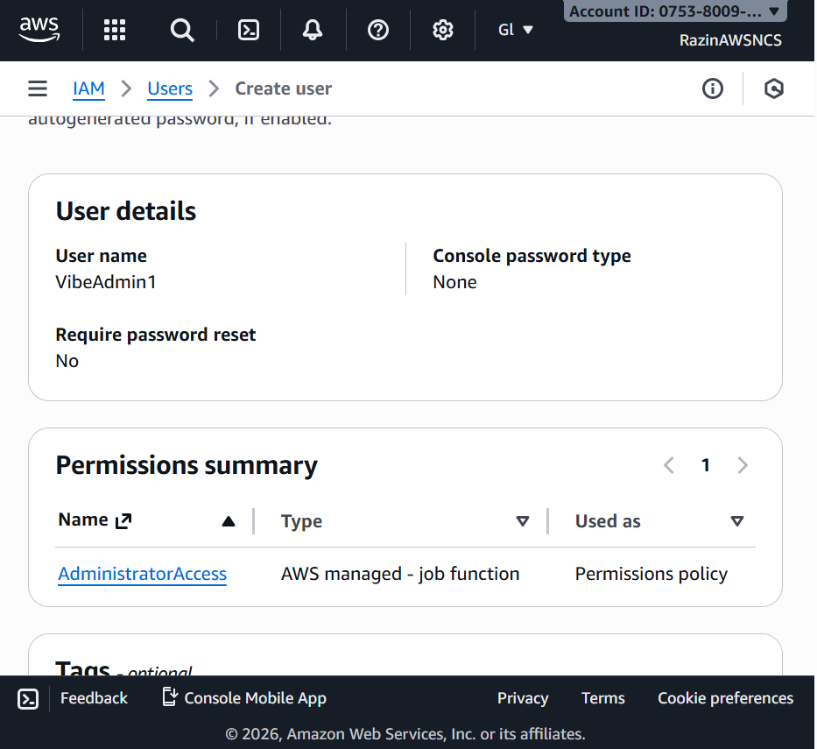
Created an Access Key for TerraForm and any other AI platforms
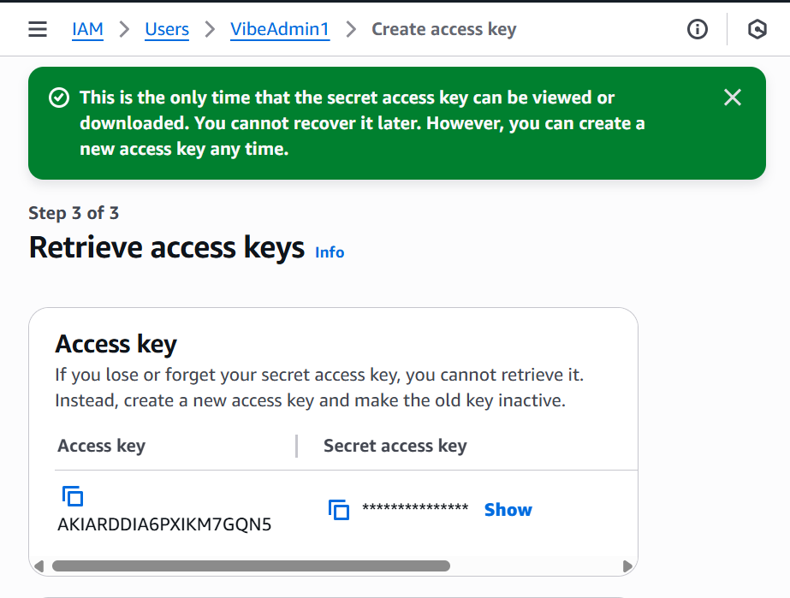
Configured the AWS CLI locally
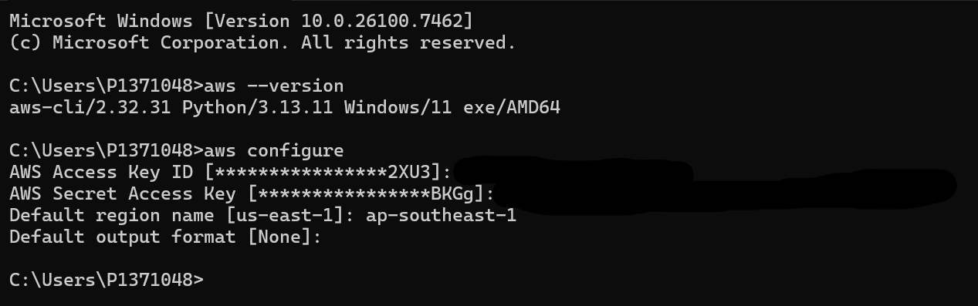
Terraform successfully initialized
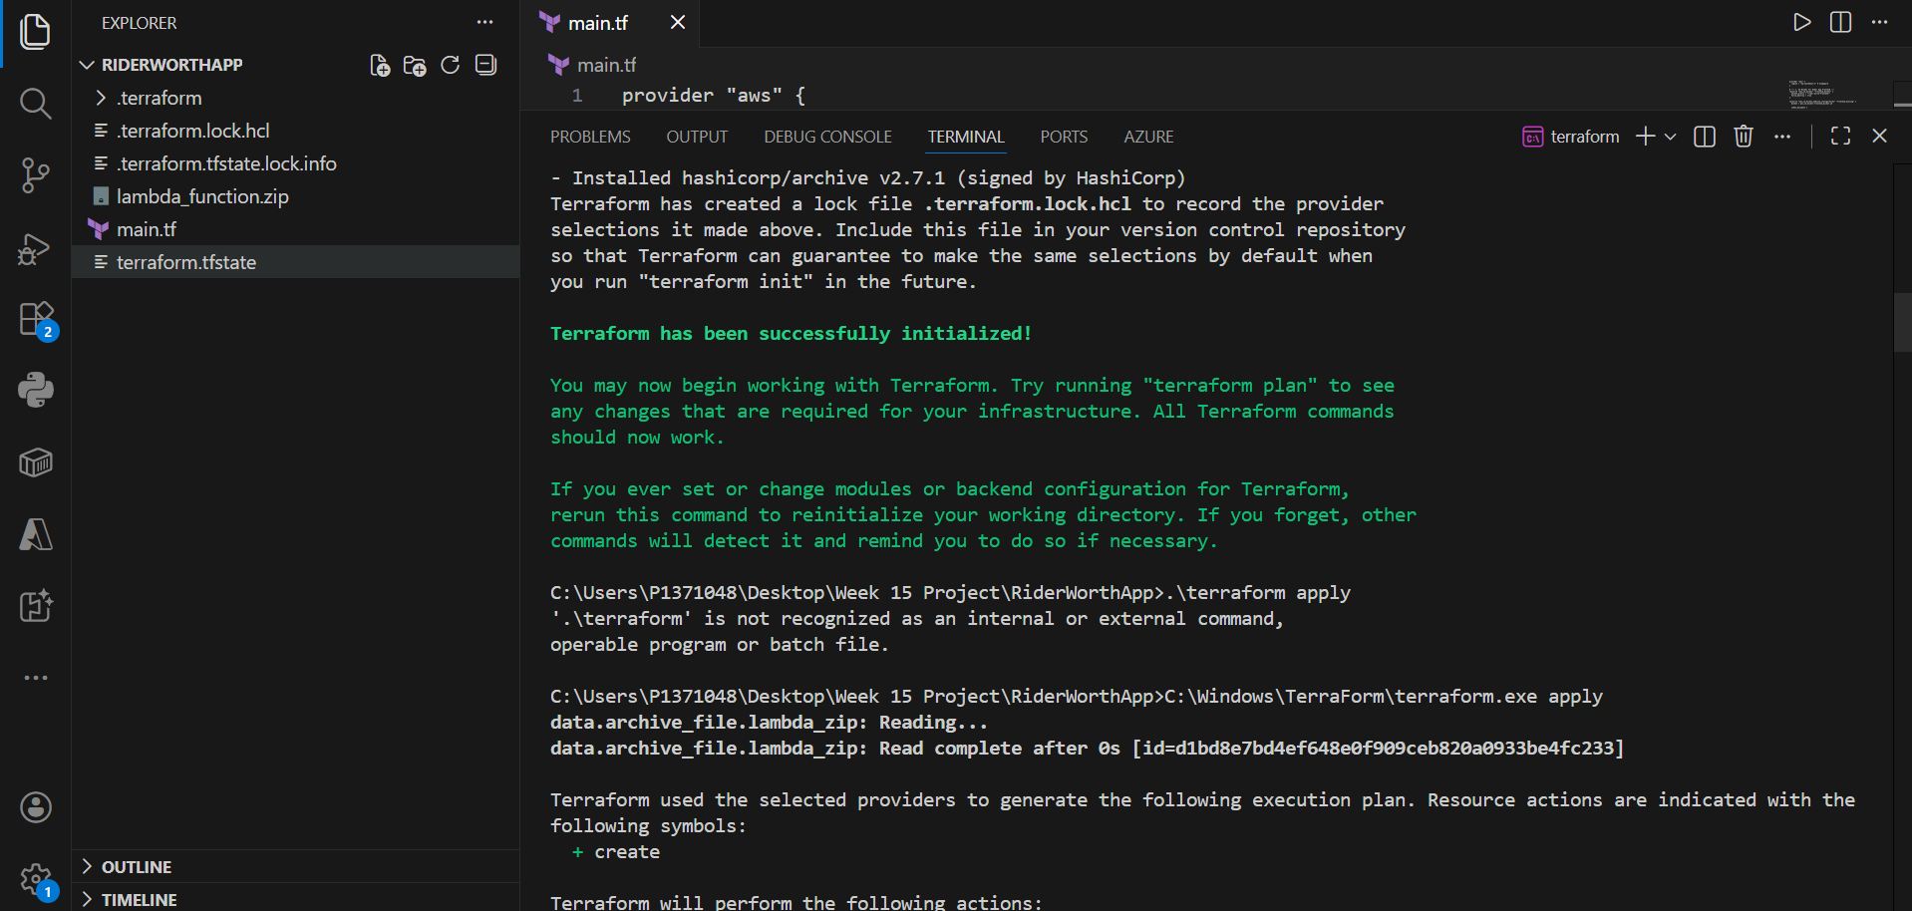
Terraform successfully created the necessary resources
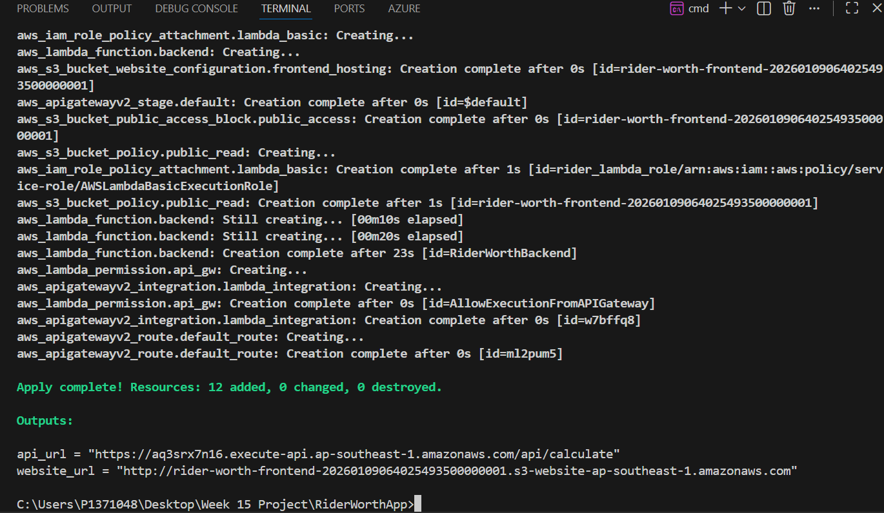
API URL :
https://aq3srx7n16.execute-api.ap-southeast-1.amazonaws.com/api/calculate
Website URL:
http://rider-worth-frontend-20260109064025493500000001.s3-website-ap-southeast-1.amazonaws.com

Terraform successfully created the necessary resources in AWS
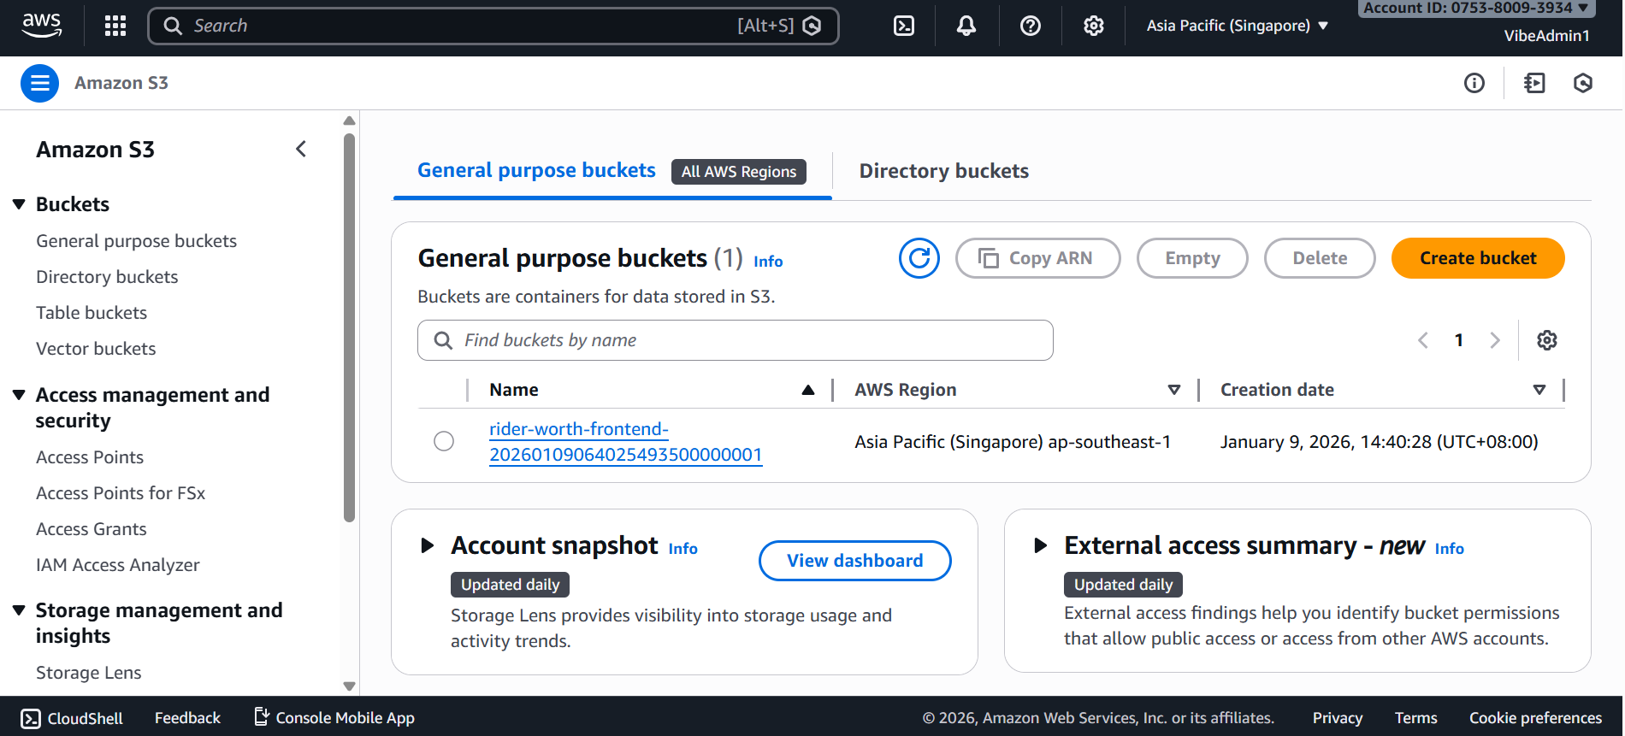
Deployed the Lambda logic in AWS
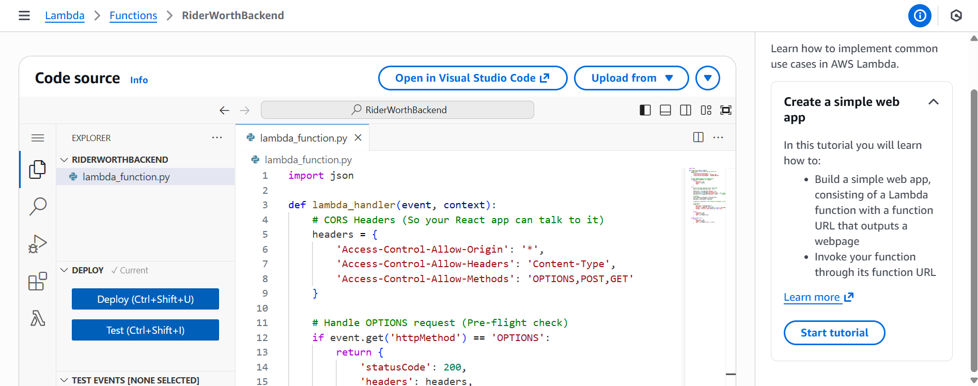

Error when modifying the source related lambda code in the main.tf file
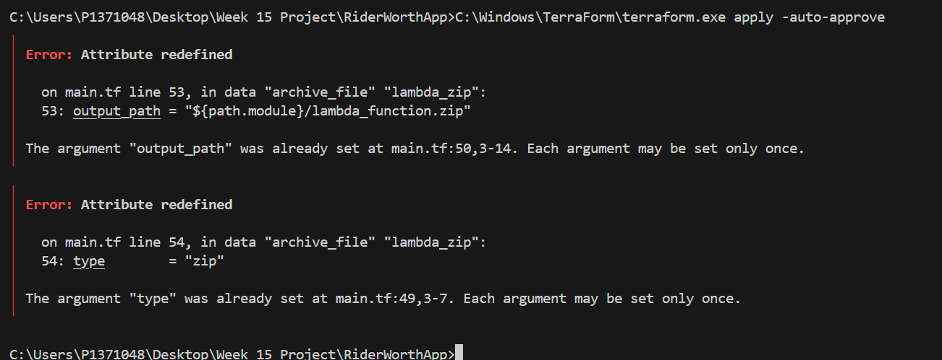
Turns out I modified the code wrongly and duplicated a variable definition
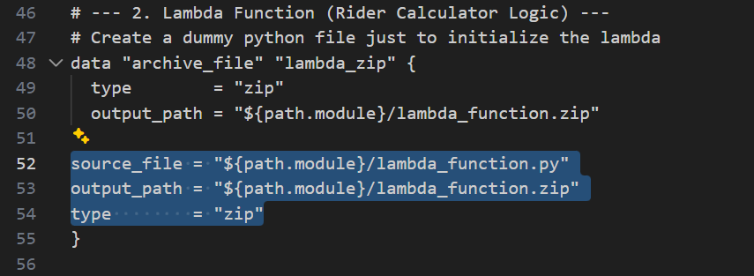
It should be like this
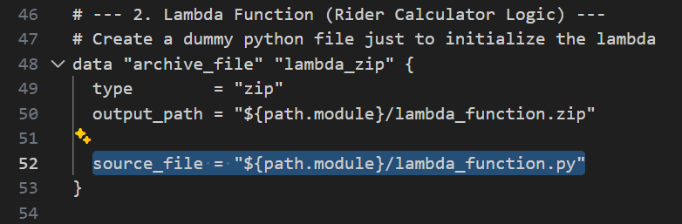
AWS S3 bucket could not be accessed via CLI; SSL verification failed.
Had to run the command with a SSL bypass due to office laptop firewall.
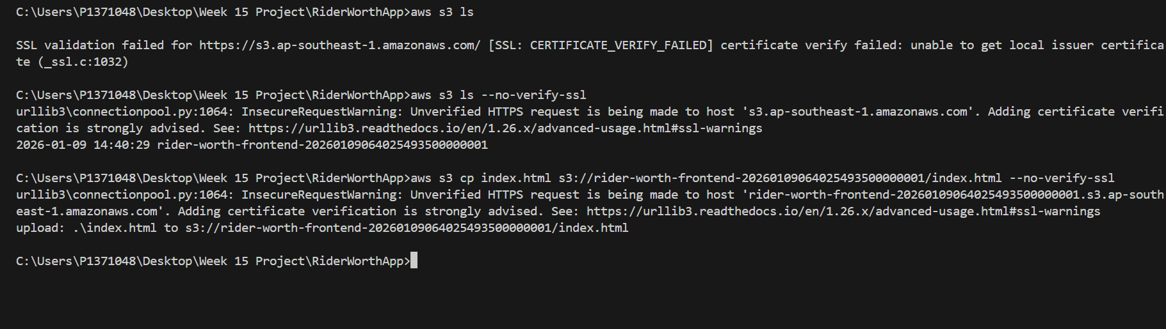
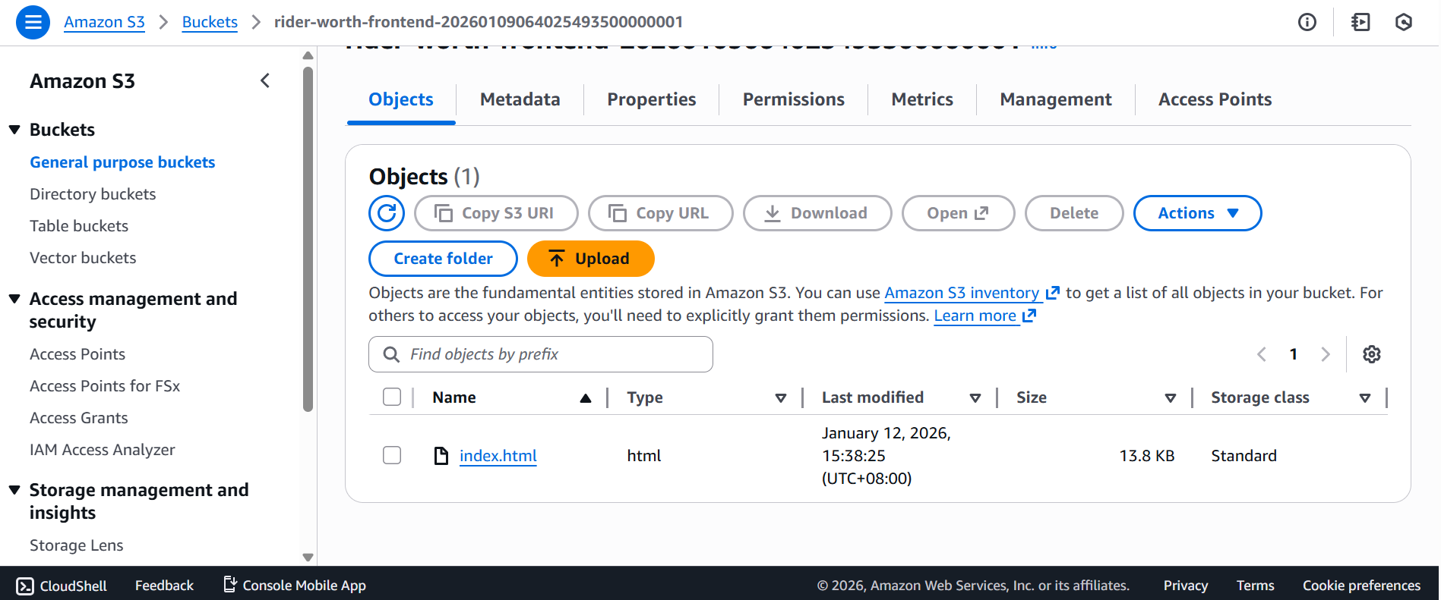
Realised the configuration could use the actual capacity of the vehicle
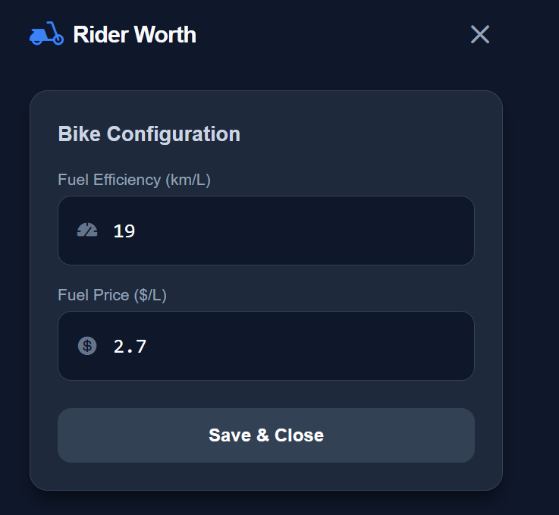
Modified it with the AI and got the desired outcome
